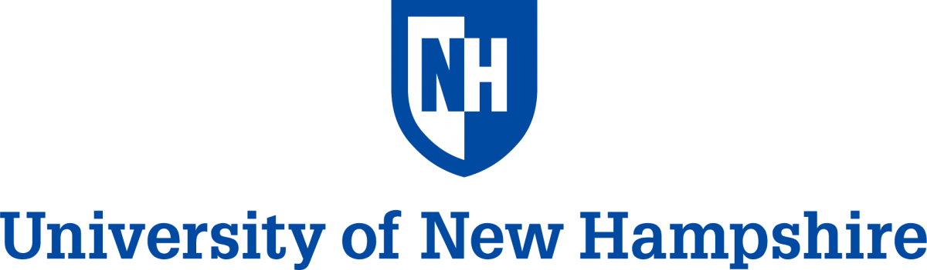

Project SMART-2023

Science and Mathematics Achievement through Research Training

“BIOTECHNOLOGY AND SOCIETY”

Department of Biological Sciences
Rudman Hall, 46 College Road,
Durham, New Hampshire 03824, USA Phone 603-862-3205, FAX: 603-862-3784

Dates: July 10 to July 28, 2023
Pre-application Deadline – June 10, 2023

NOTE: This is a preapplication to qualify for the program. More details for registration will be provided following acceptance to the program. Please fill out all parts and send to: sminocha@unh.edu.
Section 1. Information about you and your high school

Student’s Name: (Please include first, middle initial and last name)
Year of Birth: ____________________
Home Address: _______________________________________________________________
City: __________________ State: _____________ Zip:____________ Country
Home Telephone Number: ______________________
Student’s E-mail Address: ____________________ Parent’s e-mail address*: ______________
(*Parents must include their ER-mail address as per the UNH requirements for communication with minors. The E-mails will be used only for the purpose of communication about this and other academic programs at UNH).
Name of High School: ___________________________________
Current Class (Sophomore/Junior/Senior – as of July-2022): _______
School Address: ______________________________
City: ____________ State: ____________ Zip/Postal Code________ Country: ________

List the science courses you have completed in high school*
Grade 9: Science Courses ____________________________________________
Grade 10: Science Courses ____________________________________________
Grade 11 Science Courses ____________________________________________
Section 2. Please answer the following questions yourself, without assistance from parents or teachers.
A. Why are you applying to Project SMART?

B. How do you hope to benefit from the program?

C. Briefly describe the best experiences you have had in your study of science?

D. List extracurricular activities that you have participated in during high school years.

Signature of the Applicant: ______________________ Date: __________________

Permission of Parent or Guardian: I/We give permission for the above-named student, if selected, to participate in the UNH Project SMART Summer Institute. I/We will guarantee the payment of all expenses related to the Summer Institute as specified in the information package.
________________________ _______________________ ___________
Name of Parent or Guardian Signature Date

*NOTE 1: A letter of recommendation from one of your Science Teachers is required if you have not taken a biology course yet.

